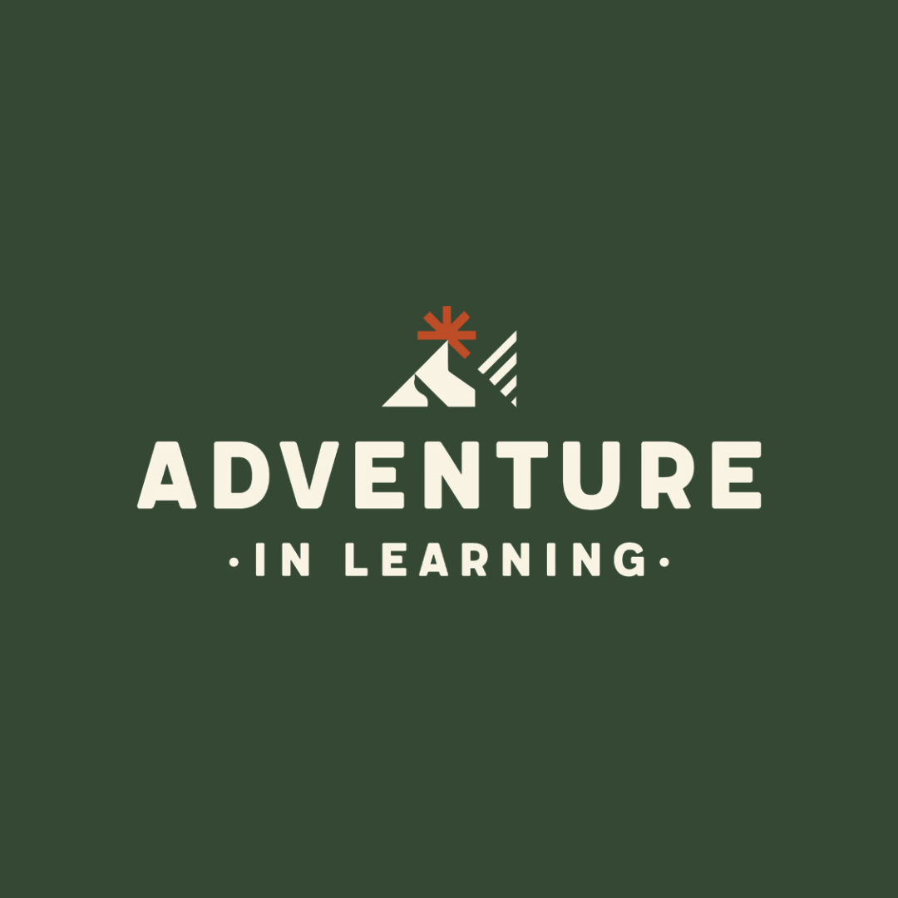

**Internet & Social Media Policy**

|  |  |
| --- | --- |
| Published | September 2023 |
| Next Review | May 2025 |
| Review Frequency | Annually |

**Introduction**

At Adventure in Learning, we believe in providing a safe and secure online environment for all our students and staff. The Internet and social media platforms are valuable tools for learning and communication, but they also present risks and potential dangers. Therefore, it is essential to establish clear guidelines and policies to ensure that everyone in our provision uses these tools appropriately and responsibly. This policy outlines the expectations and responsibilities for all users of the Internet and social media platforms within the Adventure in Learning community.

**Acceptable Use**

All users of Adventure in Learning’s Internet and social media platforms must adhere to the following guidelines:

* Respect others: Users must not use the Internet or social media platforms to harass, bully, or intimidate others. Comments, posts, or messages that are discriminatory, offensive, or inappropriate are strictly prohibited.
* Protect personal information: Users must not share any personal information, including contact details or location, about themselves or others on any public or private platform.
* Protect provision reputation: Users must not post or share any content that could harm the reputation of Adventure in Learning or its staff, students, or partners.
* Legal and ethical use: Users must comply with all applicable laws, including copyright and intellectual property laws, and ethical standards when using the Internet and social media platforms.
* Security: Users must protect their accounts and passwords and report any suspicious activity or security breaches to the Governance and Policy Lead.

These guidelines for acceptable use will be part of a pupil's inductions and the pupil/parent /carer will sign a form to note and accept the relevant guidelines. This form will be stored with the pupils record.

**Social Media Accounts**

Adventure in Learning maintains official social media accounts to communicate with students, parents, and partners. Only authorised staff members are permitted to create, manage, or post on these accounts. All posts must align with the school’s values and policies and comply with the acceptable use guidelines outlined in this policy.

**Personal Social Media Accounts**

Adventure in Learning does not regulate or monitor personal social media accounts of its students or staff. However, users must be aware that their online behaviour may impact their reputation and the reputation of the provision. Therefore, users are advised to exercise caution and follow the acceptable use guidelines outlined in this policy.

**Online Communication**

Online communication includes email, messaging, and other forms of digital communication. All users of Adventure in Learning’s online communication tools must follow the acceptable use guidelines outlined in this policy. In addition, all email communication must use professional language and tone, and be respectful and appropriate.

**Online Safety**

Adventure in Learning takes online safety very seriously. All students will receive age-appropriate digital literacy lessons that cover online safety, cyberbullying, privacy, and responsible online behaviour.

**Monitoring and Enforcement**

Adventure in Learning may monitor and review any user’s online activity on school-owned devices or accounts, including email and social media accounts. Any suspected violation of this policy may result in disciplinary action, up to and including termination or expulsion.

**Conclusion**

At Adventure in Learning, we believe in the benefits of the Internet and social media platforms but also recognize the potential risks and dangers. This policy is designed to provide clear guidelines and expectations for all users of these tools within our provision. By following these guidelines, we can ensure that our online environment is safe, secure, and conducive to learning and communication.