

**Child Protection Policy**

| Published | September 2023 |
| --- | --- |
| Next Review | May 2025 |
| Review Frequency | Annually |
| Designated Safeguarding Lead | Chris Rush |

**1. Introduction**

Adventure in Learning's child protection policy and procedures is designed to ensure the safety and well-being of all children participating in our programmes but particularly after a disclosure or concern for harm towards a child in our care is raised. It should be read in conjunction with our over-arching Safeguarding Policy.

This policy It encompasses a comprehensive framework that includes definitions of safeguarding and child protection, as well as other related policies such as behaviour, confidentiality, anti-bullying, safer recruitment, health and safety and physical intervention. It also addresses our approach to preventing and responding to concerns about radicalisation and extremism, as well as the reporting of cases of Female Genital Mutilation (FGM). With a clear statement of purpose and applicability, the policy underscores our dedication to promoting the safeguarding, welfare and safety of all children involved in Adventure in Learning activities.

One of our Directors holds the role of Designated Safeguarding Lead (DSL) and is responsible for overseeing this policy, to ensure that we work diligently to uphold our commitment to safeguarding and child protection. This policy is reviewed on a regular basis and at least annually, to ensure that it remains current and effective in addressing evolving needs and best practice.

**2. Definition of Safeguarding and Child Protection**

Safeguarding encompasses measures to protect and promote the welfare of children, ensuring they are kept safe from harm, abuse, neglect, and exploitation.

Child protection involves specific actions taken to prevent and respond to instances where a child may be at risk of or has experienced harm or abuse.

**3. Child Protection as Part of Safeguarding Responsibilities**

The policy underscores the shared responsibility of all staff members in safeguarding children and promoting their welfare within our organisation. It is imperative that every staff member remains vigilant and proactive in identifying and reporting any concerns regarding the safety, well-being, or protection of children. All staff are required to promptly inform the Designated Safeguarding Lead (DSL) of any such concerns, following established reporting procedures. This communication can be done through an initial verbal report to the DSL, however, this then needs to be documented via email, or by completing the designated safeguarding reporting form. This will ensure that the concerns are accurately documented and can be promptly conveyed to the appropriate authorities. We will foster a culture of openness, transparency, and accountability, to ensure we can collectively uphold our duty to safeguard children and create a safe and nurturing environment for their development

**4. Related Policies**

Apart from our Safeguarding Policy our child protection policy is closely linked to various related policies, including:

* Behaviour Policy
* Confidentiality Policy
* Anti-Bullying Policy
* Safer Recruitment Policy
* Physical Intervention Policy.
* Health and Safety Policy
* Equality Policy
* Whistleblowing Policy
* Prevent Policy

These policies work together to create a comprehensive framework for safeguarding children and promoting a positive and respectful environment.

As well as our own policies and procedures, we will utilise the online North and South of Tyne Safeguarding Children Procedures Manual as a reference when making specific referrals to the relevant services in our geographical catchment area.

**5. Preventing and Responding to Concerns about Radicalisation and Extremism**

Adventure in Learning is committed to preventing and responding to concerns about radicalisation and extremism among children. We have procedures and training to identify signs of radicalisation and extremism. We will then work in collaboration with relevant authorities, mainstream schools and agencies to safeguard vulnerable individuals. Our Prevent Policy will go into more details about our approach.

**6. Reporting of Cases of Female Genital Mutilation (FGM)**

Adventure in Learning acknowledges the mandatory duty to report cases of Female Genital Mutilation (FGM) that have been carried out on someone under the age of 18 to the police. We are dedicated to raising awareness about the risks of FGM and providing support to individuals affected by this harmful practice.

**7. Purpose of the Policy and Applicability**

This child protection policy serves as a guiding framework for all staff, volunteers, and participants involved in Adventure in Learning programmes. It applies to everyone within our organisation and outlines their responsibilities in ensuring the safety and well-being of children.

**8. Link to Safeguarding Children Partnership Procedures**

Adventure in Learning's child protection policy is aligned with the procedures and guidelines established by the North and South of Tyne Safeguarding Children Partnership Procedures Manual.). to ensure the effective implementation of safeguarding measures.

**9. Principles and Values**

Adventure in Learning is guided by the following principles and values in our approach to child protection:

* The welfare and safety of children are paramount.
* Every child has the right to be protected from harm and abuse.
* Safeguarding is a collective responsibility, and we promote a culture of vigilance and awareness.
* We respect the rights, dignity, and diversity of all children and families.
* Transparency, accountability, and collaboration are fundamental to our safeguarding practices.

**10. Statutory Framework and Legislations**

The statutory framework for child protection is a vital component in ensuring the safety and well-being of children across various domains. It encompasses a comprehensive list of legislation and guidance designed to safeguard children from harm and promote their welfare. Key elements include the Children Act 1989 and its subsequent amendments, such as the Children Act 2004, which establish the legal framework for child protection and the promotion of their best interests. Additionally, the Education Act 2002 outlines the responsibilities of educational institutions in ensuring the safety and security of their students. The policy also references essential guidance documents such as "Working Together to Safeguard Children (2015)" and "Keeping Children Safe in Education (2015)," which provide overarching principles and procedures for child protection practices. Furthermore, specific legislative measures are highlighted, such as the Prevent Duty for England and Wales (2015), aimed at safeguarding children from the threat of radicalization and extremism. Provisions under the Female Genital Mutilation Act 2003, as amended by the Serious Crime Act 2015, address the prevention and prosecution of this harmful practice. Moreover, guidance on dealing with allegations of abuse against teachers and staff is outlined, emphasising the importance of robust safeguarding procedures within educational settings. The policy underscores the significance of adhering to North and South of Tyne Safeguarding Children Partnership (SCP) Procedures Manual, which delineate the roles and responsibilities of various stakeholders in safeguarding children. It also directs schools to relevant SCP requirements and procedures, ensuring compliance with local safeguarding protocols and facilitating effective collaboration between agencies involved in child protection.

Overall, the statutory framework outlined in the policy underscores a commitment to prioritising the safety, security, and well-being of children within educational environments.

**11. When to be concerned?**

The policy delineates the four primary categories of abuse: physical abuse, emotional abuse, sexual abuse, and neglect.

Physical abuse involves the infliction of physical harm or injury upon a child, including hitting, punching, shaking, or other forms of physical violence.

Emotional abuse encompasses behaviours that undermine a child's emotional well-being, such as constant criticism, humiliation, or threats of harm.

Sexual abuse involves any form of sexual activity imposed on a child, including molestation, rape, or exploitation for the purposes of gratification or profit.

Neglect refers to the failure to provide for a child's basic needs, including food, shelter, clothing, medical care, and supervision, leading to harm or impairment of the child's health or development.

We provide guidance to staff members on recognizing potential signs of abuse and taking appropriate action to safeguard the welfare of children. By familiarising themselves with these categories and associated indicators, staff members can effectively identify and respond to concerns regarding child abuse, thereby fulfilling their duty to protect and support the well-being of children within our organisation.

**12. Dealing with Concerns or Disclosures**

1. **Procedures for managing concerns about a child.**

Staff at Adventure in Learning will report any concerns that they have and not see these as insignificant. Staff should not assume a colleague or another professional will take action and share the concern. On occasions, a referral is justified by a single incident such as an injury or disclosure of abuse. More often, however, concerns accumulate over a period of time and are evidenced by building up a picture of harm over time; this is particularly true in cases of emotional abuse and neglect. In these circumstances, it is crucial that staff record and pass on concerns to allow the DSL to build up a picture, and hold discussions with the pupil(s) home school in order to assess support for the child at the earliest opportunity. The DSL will then record the concern and action taken in the pupil(s) individual file along with the outcome.

(See Appendix 1 for Procedures for responding to a concern flowchart).

***3.1 Staff must immediately report:***

* Any suspicion that a child is injured, marked, or bruised in a way which is not readily attributable to the normal knocks or scrapes received in play/everyday, normal activities, especially where Any explanation given which appears inconsistent or suspicious.
* Any behaviours which give rise to suspicions that a child may have suffered harm (e.g. worrying drawings or play, actions)
* Any concerns that a child may be suffering from inadequate care, ill treatment, or emotional maltreatment
* Any concerns that a child is presenting signs or symptoms of abuse or neglect
* Any significant changes in a child’s presentation, including non-attendance
* Any hint or disclosure of abuse from any person
* Any concerns regarding person(s) who may pose a risk to children (e.g. living in a household with children present)
* Any hint or disclosure of sexual exploitation
* That a child has witnessed domestic abuse or is in a household where domestic abuse is taking place

Children can sometimes show signs or act in ways they hope adults will notice and react to. All staff should be aware of this and remain vigilant. Staff must also consider children who might present as vulnerable.

***3.2 What staff should do if a child is in danger or at risk of harm***:

If staff are concerned that a child could be at risk of harm they must report to the Designated Safeguarding Lead (DSL) immediately and the pupil(s) mainstream school. If this is not possible, they should make a direct referral to children’s social care. All actions will be recorded in each pupil’s individual file.

***3.3 Responding to Disclosure:***

Disclosures or information may be received from pupils, parents or other members of the public. Adventure in Learning recognises that those who disclose such information may do so with difficulty, having chosen carefully to whom they will speak. Accordingly, all staff will handle disclosures with sensitivity. Such information cannot remain confidential and staff will immediately communicate what they have been told to the Designated Safeguarding Lead. Staff will not investigate but will, wherever possible, elicit enough information to pass on to the Designated Safeguarding Lead in order for an informed decision to be made regarding the next steps.

Staff will:

* Listen to and take seriously any disclosure or information that a child may be at risk of harm
* Try to ensure that the person disclosing does not have to speak to another member of staff
* Clarify the information
* Try to keep questions to a minimum and of an ‘open’ nature e.g. ‘Can you tell me what happened?’ rather than ‘Did x hit you?’
* Try not to show signs of shock, horror or surprise
* Not express feelings or judgments regarding any person alleged to have harmed the child
* Explain sensitively to the person that they have a responsibility to refer the information to the senior designated person
* Reassure the person that they will be taken seriously, supported and kept safe
* Listen to and take into account (wherever possible) the child’s wishes and feelings about the current situation as well as future plans
* Ask any necessary questions to determine the child’s wishes and feelings.
* Explain that only those who ‘need to know’ will be told
* Explain what will happen next and that the child will be involved as appropriate
* Ensure there is appropriate support made available

Any member of staff or visitor to the provision who receives a disclosure of abuse or suspects that a child is at risk of harm or immediate danger must record the details in writing as soon as possible after following the above guidance and then report it immediately to the DSL who will the report the matter to the pupil(s) mainstream school. In the absence of the DSL or being unable to contact the mainstream school , the matter should be brought to the attention of the relevant Safeguarding Hub or Local Authority Children Social Care Team.

All concerns about a child or young person should be reported without delay and recorded in writing. Staff must discuss this with the Designated Safeguarding Lead (DSL).

Following receipt of any information that raises concern, the DSL will consider what action to take and seek advice from Children’s Services or the mainstream school as required. All concerns, discussions and decisions made, and the reasons for those decisions should be recorded in writing.

All referrals will be made in line with Keeping Children Safe in Education Guidance and the Local Children’s Services’ procedures.

If, at any point, a child is in need of immediate protection or there is a risk of significant harm to a child, a referral should be made to Children’s Services immediately and, if a criminal offence has possibly been committed, contact the police. Anybody can make a referral in this situation but, ideally, this will be undertaken by the DSL. If the child’s situation does not appear to be improving, then the staff member with concerns should press for reconsideration by raising concerns again with the DSL. Concerns should always lead to help for the child at some point.

Staff should always follow the reporting procedures outlined in this policy in the first instance. However, they may also share information directly with Children’s Services or relevant Safeguarding Hub, or the police if:

* The situation is an emergency and the Designated Safeguarding Lead and/or the pupil(s) mainstream contact are all unavailable
* They are convinced that a direct report is the only way to ensure the pupil’s safety

1. **Complaints/Allegations Made Against Staff**

Adventure in Learning takes seriously all complaints made against members of staff. All such complaints will be brought immediately to the attention of the Designated Safeguarding Lead. These procedures are used in respect of all cases in which it is alleged that a member of staff (including volunteers) has:

* Behaved in a way that has harmed a child, or may have harmed a child;
* Possibly committed a criminal offence against or related to a child; or
* Behaved towards a child or children in a way that indicates he or she would pose a risk of harm to children.

The DSL will contact the relevant school’s DSL to report the allegation. Adventure in Learning or the mainstream contact will then contact the Local Authority’s Designated Officer(s) (LADO) to inform them of all allegations that come to attention.

An allegation of child abuse made against a member of staff may come from a parent, another member of staff or from a child’s disclosure.

We will:

* report such allegations following the appropriate procedures record the details that give cause for concern
* contact relevant agencies for advice
* consider suspending the member of staff or withdrawing them from contact with pupils until a thorough investigation has taken place
* cooperate fully with the process of Social Care and the Police investigations
* support and treat with respect the member of staff whilst suspended or on other duties
* If the result of the investigation is that it was a false allegation, give the staff member the appropriate support

If the allegation is made against the DSL then the most senior member of staff on duty will undertake the DSL role in this case.

Additional support for both staff and children who may be affected by abuse can be found online via the North and South of Tyne Safeguarding Children Partnership (SCP) Procedures Manual. This includes contact information for local child protection services, and national helplines or support organisations specialising in child welfare and protection issues.

By providing clear guidance on dealing with disclosures of abuse, as well as access to support services and regular update training, we will ensure that our staff members are equipped to respond effectively to safeguarding and child protection concerns and prioritise the well-being of children within our organisation .

**13.Confidentiality**

In accordance with our commitment to safeguarding children, all staff members are responsible for sharing pertinent information related to the protection and welfare of children with the DSL mainstream school and other relevant professionals. This responsibility extends to disclosing information that may raise concerns about a child's safety, well-being, or protection from harm. It is essential for staff members to collaborate with the DSL and other professionals to ensure appropriate action is taken to safeguard the child effectively. Remove unless you have such a policy

Moreover, our policy emphasises the importance of sharing information about children and families solely within a professional context. Staff members are expected to exercise discretion and caution when sharing information, ensuring that it is done in accordance with legal and ethical guidelines. Information should be shared only on a need-to-know basis and strictly for the purpose of safeguarding and promoting the welfare of children. By adhering to these principles, we uphold the trust and confidentiality of children and families while fulfilling our duty to safeguard children within our care.

**14.Communication with Parents, mainstream school and local authorities (where a child is not placed in a mainstream school*)**

***(*Where a child is not currently placed with a mainstream school, our point of contact will be via the relevant inclusion officer for the placing local authority. Therefore, when this occurs the term mainstream school will refer to the relevant inclusion officer)***

Our communication with the mainstream school and parents regarding the school's responsibilities for safeguarding children is of paramount importance. In the event of a safeguarding concern that requires referral to other agencies, such as child protection services or healthcare professionals, the mainstream school and parents are informed promptly and transparently (unless, in the case of a referral that may implicate the parents as abusers, we will take advice on what specific course of action to take from either the mainstream school, police or social services). We communicate with parents openly, ensuring they understand the reasons for any necessary referrals and the steps being taken to ensure the safety and well-being of their child.

Should parents have any concerns regarding safeguarding or the welfare of their child, they are encouraged to contact our DSL or another senior member of the team. Contact information for the DSL is readily available on our organisations website. Our aim is to foster a supportive and collaborative relationship with parents, ensuring they feel confident in raising concerns and working together with us to safeguard their children**.**

**15.Record Keeping**

Our policy provides clear guidelines for staff on how to record both concerns and disclosures regarding safeguarding issues. When a concern arises or a disclosure is made, staff members are instructed to document the details promptly and accurately using our safeguarding spreadsheet, which serves as our designated recording tool.

By adhering to these recording guidelines and utilising our safeguarding spreadsheet, staff members can ensure that concerns and disclosures are documented consistently and comprehensively, facilitating effective communication, monitoring, and follow-up actions to safeguard the welfare of children within our care.

**16. Allegations against staff**

**What staff should do if they are concerned about a colleague’s behaviour:**

Staff to report any concerns they have about a colleague's behaviour promptly via.

* + speaking to a senior member of staff or DSL
  + Emphasise confidentiality and protection for whistleblowers by reference to our whistle blowing policy???
  + The DSL will outline any specific procedures or forms that need to be followed when reporting concerns.

Adventure in Learning takes seriously all complaints made against members of staff. All such complaints will be brought immediately to the attention of the Designated Safeguarding Lead. These procedures are used in respect of all cases in which it is alleged that a member of staff (including volunteers) has:

* Behaved in a way that has harmed a child, or may have harmed a child;
* Possibly committed a criminal offence against or related to a child; or
* Behaved towards a child or children in a way that indicates he or she would pose a risk of harm to children.

The DSL will contact the relevant school’s DSL to report the allegation. Adventure in Learning or the mainstream contact will then contact the Local Authority’s Designated Officer(s) (LADO) to inform them of all allegations that come to attention.

An allegation of child abuse made against a member of staff may come from a parent, another member of staff or from a child’s disclosure.

We will:

* report such allegations following the appropriate procedures record the details that give cause for concern
* contact relevant agencies for advice
* consider suspending the member of staff or withdrawing them from contact with pupils until a thorough investigation has taken place
* cooperate fully with the process of Social Care and the Police investigations
* support and treat with respect the member of staff whilst suspended or on other duties
* If the result of the investigation is that it was a false allegation, give the staff member the appropriate support

If the allegation is made against the DSL then the most senior member of staff on duty will undertake the DSL role in this case.

**Appendices**

**Appendix A.**

***Responding to a concern.***

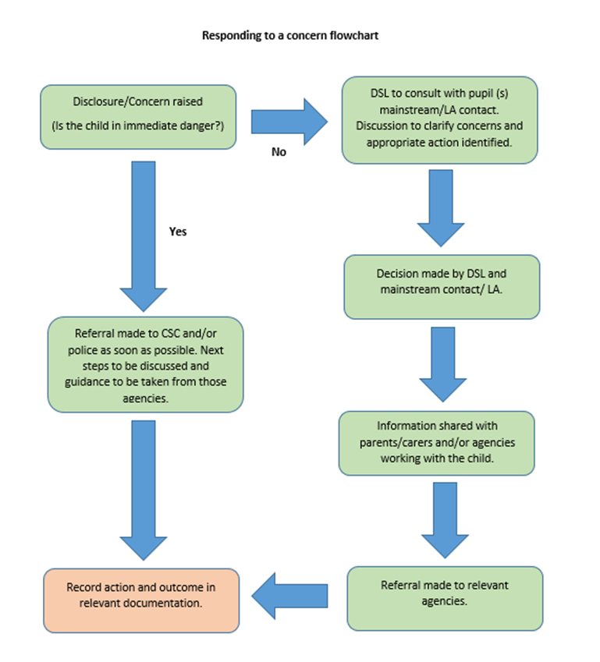

**Contact Details**

We will utilise the North and South of Tyne Children Partnership website and referral forms for the up to date contact details of relevant organisations regarding any potential advice or referrals

20th May 2024